--------------------------------------------------------------------------------------------------------

---------------------- ADD ODOO MODULE AFTER INSTALLATION ---------------

--------------------------------------------------------------------------------------------------------

In this tutorial, we're going to add new module on odoo addons after inatllation.

To begin, we’re going to download the zip file on odoo platform store.

Go on : <https://www.odoo.com/apps/themes>and search your theme.

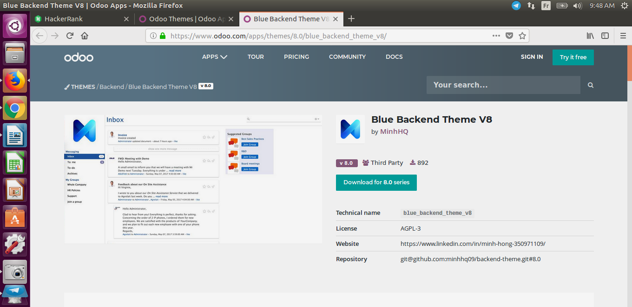

Click on download to get theme on your local machine.

Now, we’re going to extract file and push it on our odoo addons directory.

1. Open the CLI and connect user root as :

**sudo su**

2. Unzip theme :

**unzip** zip_file

3. Run this command to copy theme in the addons directory :

cp -R theme_actual_directory odoo_addons_directory

Like this in my case :

**cp -R blue_backend_theme_v8 /opt/odoo/addons/**

Now, you must restart your odoo service and log in your web browser.

4. Active technical mode (when you’re login as administrator)

Under **setting** tab, select **users**

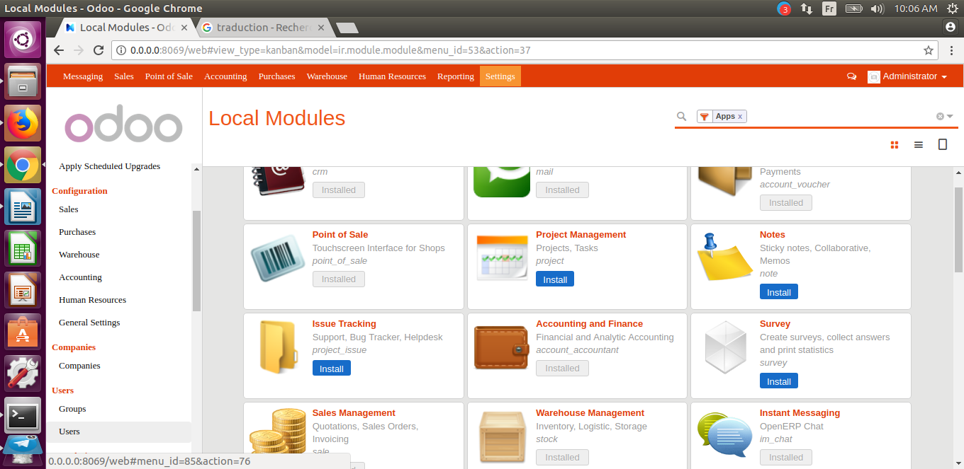

Blue line above show when you must click**.**

After that, select **admin user** and **edit**’it. Show the blue line on the right.

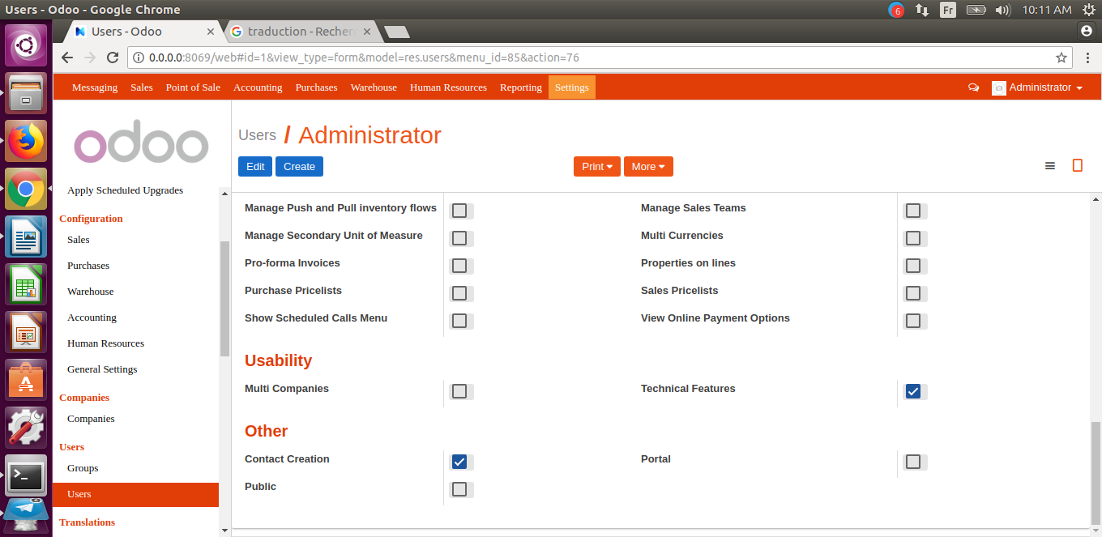

5. Update modules list

Go back on **setting, modules** tab.

Click on **Update Modules List** link and search your module recently added on **Local Modules**

In my case :

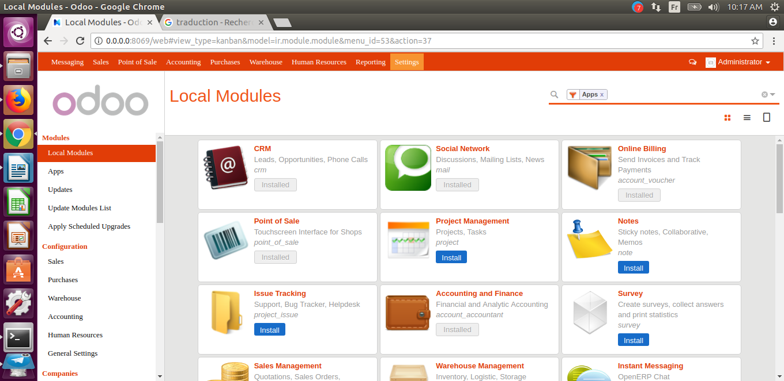

Delete **Apps** on search file (follow the blue line) and type your module name and click on **install** button.

This is the new theme set up…

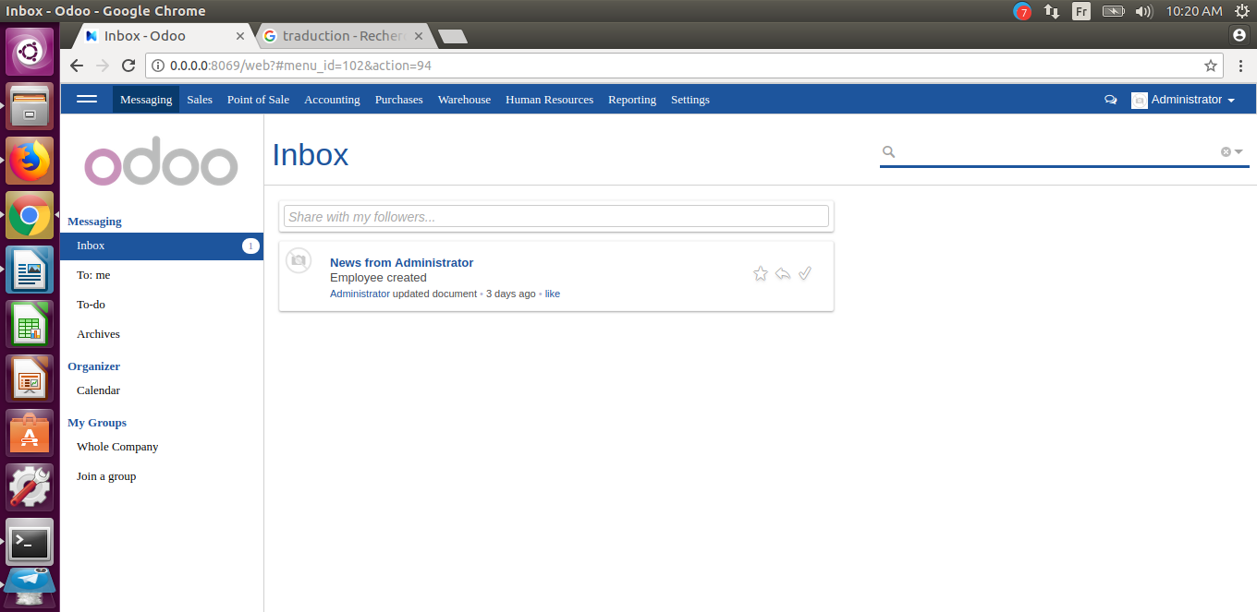

**END ! ! !**